A Symbiotic System Approach for the Development of Canadian Oil Sands

And The Potential For Positive Impact On The Decision To Build The Keystone Pipeline

Prof. Alexander H. Slocum (slocum@mit.edu)

Massachusetts Institute of Technology

David Taylor (dtaylor@mit.edu)

Massachusetts Institute of Technology

Santiago Paiva (santiago.paiva@cs.mcgill.ca)

McGill University

**Abstract**

We propose a symbiotic system approach for the development of Canadian Oil Sands. We show, for example, if 20% of Canadian Oil Sands income were to be invested in renewable-energy machines as part of reclamation efforts for the land that is mined for the oil sands, then in 30-40 years as much CO2 will have been kept from the air from burning coal to make electricity as was released into the air from mining the oil sands and consuming the oil. Furthermore, in a period of excess electricity power generation, the power can be used to clean contaminated water of Poly-Aromatic Hydrocarbons (PAH) and hydrocrack PAH into useful compounds.

Contents

1 Introduction 3

1.1 Motivation 3

1.2 Problem Domain 3

2 Alberta's Oil Sands Oil Analysis 6

2.1 Mining and Production of Oil Sands 6

2.2 The Keystone XL Pipeline 6

2.3 Social, Environmental, and Health Impact 7

Water Contamination 7

Risk of accidents 7

3 CO2 Saved From Investing in Wind Energy 7

3.1 Wind Energy Analysis 7

3.2 Results from Investing in Wind Energy 10

3.3 The CO2 offset percentage 11

3.4 Assumptions 12

4 CO2 Saved From Investing in Solar Energy 12

4.1 Solar Energy Analysis 12

4.2 Results from Investing in Solar Energy 14

4.3 The Offset Percentage 15

4.4 Assumptions 15

7 Discussion 16

8 Conclusion 16

References 18

# 1 Introduction

## 1.1 Motivation

Beneath the boreal forest in Northern Canada lies the world's 2nd largest oil reserve, known as the oil sands. The oil sands are a mixture of sand and a heavy crude oil called bitumen. Natural bitumen is reported in 598 deposits in 23 countries, with the largest deposits in Canada, Kazakhstan, and Russia. Bitumen reserves are estimated at 249.67 billion barrels out of which 178 billion barrels (70.8%) are in Canada (Alberta) [1].

The Northern Alberta region contains 98% of the Canadian oil sand oil industry and it is divided into three regions:

* The Athabasca-Wabiskaw deposits region
* The Cold Lake deposits regions
* The Peace River deposits region

Together, they cover 140,200 square kilometers [2].This is equivalent to a region bigger than England. It is also estimated by the Government of Canada that these regions hold proven reserves up to 1.75 trillion barrels of bitumen in place [9]. In addition, 173 billon barrels (10%) estimated to be recoverable at current prices using current technology.

This amounts to 97% of Canadian Oil reserves and 75% of total North American petroleum reserves. It is further estimated that 90% of the Alberta oil sands are too far below the surface to use open-pit mining. As a consequence, the Canadian government has decided the creation of the Keystone XL pipeline which would allow mining companies to get further access to the mineral.

However, it is estimated that the environmental and health factors resulted as a by-product of these pipeline does not outweigh the benefits of building such a pipeline. In this paper, we demonstrate how better alternatives such as investment in Wind Turbines and Photovoltaic (PV) Solar Cells not only will result in a significant reduction of CO2 emissions, but prove to be a solid green option for the future of Alberta and the country.

## 1.2 Problem Domain

The Province of Alberta is currently operating on poor energy return per area invested. Alberta's Oil Sands are being mined over a vast area which will destroy large swaths of forests releasing even more carbon into the atmosphere. Just mining the oil and consuming it could have a huge impact on climate change. Poisson *et al* [17] recently demonstrated that since the 1990s, the total energy used (invested) in the Canadian oil and gas sector increased approximately 63%, while energy production (return) increased only 18% resulting in a decreased total energy return on investment (EROI) from 16:1 to 11:1. In the spirit of increasing the EROI from this vast resource, we present a possible better EROI for the area and the country.

**Hypothesis:**

*The effect of oil sands utilization on climate change does not have to be negative IF as part of land reclamation of the mined oil sands area, developers of the oil sands resource were required to plan and invest for when the oil sands are depleted. This scenario could include for every square kilometer of land to be reclaimed, a 5 MW wind turbine is installed. The power from the turbine can be used for oil sands production and also sold to the grid.*

Figure 1 below shows an example cumulative effect on CO2 emissions over the years of this land reclamation plan, with 50% of the total oil sands land area being reclaimed with wind turbine installations. Similar results are obtained with 10% of the area reclaimed using arrays of PV cells

This requires oil sands developers to invest a portion of sales, $20/bbl for the scenario here, into renewable energy production; however, this is not a tax in which money is paid to the government and the companies never receive a direct benefit. On the contrary, the money invested benefits the oil sands companies directly and immediately because they can use the electric power for production of the oil sands instead of having to build more transmission lines to bring power in for which they then have to pay to use. Furthermore, once the number of turbines increases to a point, they can start sending power out on the same power lines they initially had installed to bring power in (are in the process of installing) to develop the oil sands.

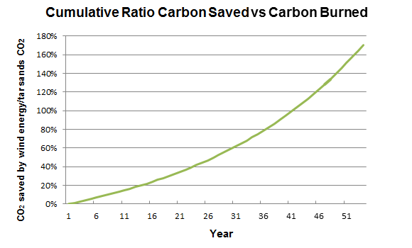

**Figure 1.** Amount of CO2 offset by 20% investment in Wind Turbines based on $4/Watt installed. See supplemental materials for spreadsheet to enter different values

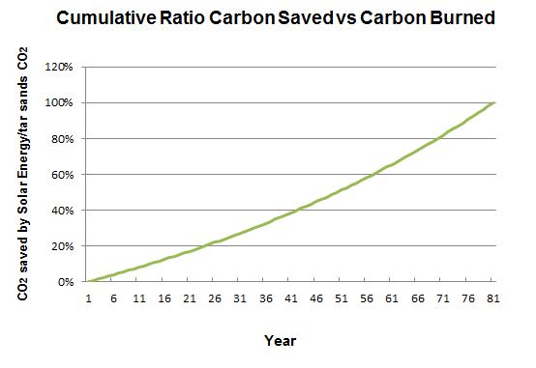

**Figure 2.** Amount of CO2 offset by 20% investment in PV Solar Cells based on $4/Watt installed, with up to a maximum of 15% efficiency, covering 30% of the land from a 10% of all total land. See supplemental materials for spreadsheet to enter different values

# 2 Alberta's Oil Sands Oil Analysis

## 2.1 Mining and Production of Oil Sands

Per day, oil sands operation release as much CO2 as all the cars in Canada

[8]. Enough natural gas is burned to heat 4 million homes daily, while local upgraders emit 300 tonnes of sulphur. The Athabasca River is part of the third largest watershed in the world. Processing one barrel of bitumen requires approximately three barrels of water [8]. The contaminated water is then pumped into giant tailings ponds alongside the shore.

According to a report released in 2011 [3], production of oil sands released an estimated of 47.1 million metric tonnes of CO2 into the air. Considering that in 2011, 1.8 million barrels a day were produced, we obtain the following chart:

**Table 1: CO2 from Oil Sands production and oil use**

|  |  |
| --- | --- |
| **Production** | **Use** |
| Oil produced (million barrels per year) | 693.5 |
| CO2 to produce the oil (megatonnes/year) | 50 |
| CO2 from oil use (megatonnes/year) | 298.2 |
| **Total CO2 from Oil sands (megatonnes/year)** | **348** |

The recent announcement of the Keystone XL pipeline would allow the oil sand oil industry to propel mining and production to a whole new level. However, it raises the question: is the proposed Keystone XL pipeline the most environmental friendly option compared to other alternatives? There is a better alternative.

## 2.2 The Keystone XL Pipeline

As mentioned, the pipeline is a major milestone in the next phase of extracting oil sands under Canada's Boreal Forest to reach higher prices of overseas markets.

Projected Impact of Keystone XL by FEIS [4]:

* Projected 830,000 barrels/day flow
* Add between 147 to 168 million metric tons of greenhouse gas emissions annually
* According to FEIS, the pipeline would be \unlikely to significantly impact the rate of extraction in the oil sands, or the continued demand for heavy crude oil at refineries in the United States." Those greenhouse gas emissions from oil sands oil would probably be produced with or without Keystone.

In a recent article by Environment News Service, two senators called on the Secretary of State John Kerry and the Obama Administration to conduct “an immediate and comprehensive study" of the public health risks to communities from the proposed Keystone XL pipeline would carry diluted bitumen from Alberta across the US-Canada border to refineries on the Texas Gulf Coast [5].

Canada's position has been clear: oil sands will be mined whether or not Keystone XL ever gets built. However, in addition to directly benefitting citizens of Canada and the US with renewable electric power and long term CO2 reduction, the proposed option presented here might turn many US opponents of the pipeline into supporters.

## 2.3 Social, Environmental, and Health Impact

### Water Contamination

The Province of Alberta is creating man-made lakes to store the contaminated water produced from the process used to turn bitumen into diesel and other fuels. Reservoirs filled with oil sands wastewater are predicted to cover almost 62,000 acres by 2020 [14].

In these contaminated waters we find high levels of “[Polycyclic Aromatic Hydrocarbons](http://en.wikipedia.org/wiki/Polycyclic_aromatic_hydrocarbons)” or PAHs. Some applications of this compound includes to make dyes,

**plastics,** and **pesticides**. Some are even used in medicines (treat some skin disorders in humans)

For a barrel of water, how much is in it?

### Risk of accidents

Pipelines spill more often than rail - over the past decade, pipelines have spilled 474,441 barrels of oil, compared to the 2,268 barrels spilled over the same time by rail. Pipeline spills also tend to be larger than rail spills - witness the 2010 Enbridge oil spill, when a burst pipeline led to more than 23,000 barrels of oil pouring into Michigan's Kalamazoo River. Fears over similar accidents have helped put the proposed Keystone XL pipeline on hold (environmentalists have raised concerns that spills involving oil sands crude will be especially difficult to clean). But pipeline spills remain rare as well, and the ones that do occur pose a more direct threat to the environment than to people - unlike rail accidents [15].

# 3 CO2 Saved From Investing in Wind Energy

## 3.1 Wind Energy Analysis

The debate does not have to be so difficult, however, if a systems perspective is pursued; hence herein is proposed the following scenario:

If one were to install one 5MW wind turbine per kilometer square in a total of

70,100 kilometers square land area (50 % of the Alberta Oil sands area), it would require an investment of about 20% of the portion of the sales (e.g., $20/bbl). This approach would offset the CO2 created by mining and using the oil sands oil in approximately 35 years while producers can benefit from the use of electric power for mining and production of the oil sands.

Furthermore, it is common for the return on investment period for a wind turbine to be about 10-15 years, which means the $20/bbl invested is actually fully recouped in 10-15 years and then onward the wind turbine becomes a net income producer. [ref]

It is estimated that the CO2 released (and captured) from boreal forest is about 26.2 tonnes/km2 [13]. This value is small compared to CO2 offset by having a large wind turbine (8500 tonnes/year/MW by not burning coal to produce energy generated by wind). Therefore, this is a strong motivation for oil sands land mining reclamation to not to just replant the forest, but to plant forest *and* a large high hub height wind turbine every square kilometer. Figure 3 shows different scenarios for different percentage of investment.

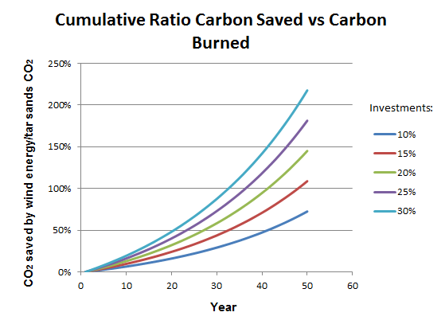

**Figure 3.** Amounts of CO2 offset with different investments in Wind Energy

**Table 2.** Amount of CO2 saved by Wind Turbines

|  |  |
| --- | --- |
| **Description** | **Value** |
| Turbine Peak Power (MW) | 5 |
| Capacity factor | 40% |
| Land area per turbine (km2) | 1 |
| Percent land area for wind turbines | 50 % |
| Area of wind farm (km2) | 70,100 |
| (Square Miles) | 27,383 |
| Square size (miles x miles) | 165 |
| Something | Something |
| Number of turbines to be built for land area | 70,100 |
| Average Power generated (GW) | 198 |
| Average annual energy produced (TWHr) | 1,734 |
| **CO2 saved by wind turbines (megatonnes/year)** | **1,684** |

## 3.2 Results from Investing in Wind Energy

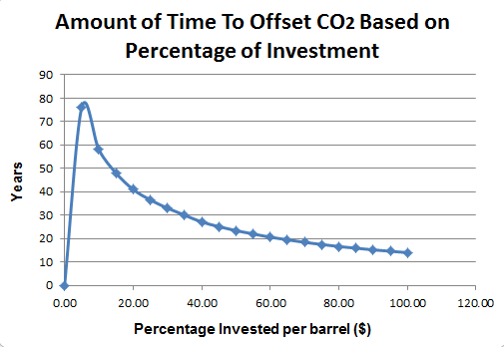

**Figure 4.** CO2 offset timelines with different investments in Wind Energy

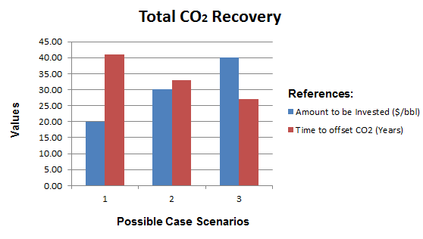

**Figure 5.** Case scenarios to offset CO2 with Wind Energy

**Estimated Results For Wind:**

* 15% Investment will produce an offset of CO2 in 48 years
* **20% Investment will produce an offset of CO2 in 41 years**
* 25% Investment will produce an offset of CO2 in 36.5 years
* 30 % Investment will produce an offset of CO2 in 33 years
* 40 % Investment will produce an offset of CO2 in 27 years

## 3.3 The CO2 offset percentage

The CO2 offset percentage is obtained with the following formula:

$${Carbon}_{offset}= \frac{Amount of CRCS (Cumulative Ratio Carbon Saved)}{Amount of CB (Carbon Burned)}$$

To compute the amount of CRCS (Cumulative Ration Carbon Saved):

$${CRCS}_{t+1} ={CRCS}_{t }+ \frac{{\# installed wind turbines}_{t}}{\# total turbines to be built for land area}× α$$

Where:

* $α= {CO}_{2} saved by not burning coal to produce energy generated by wind$ from Table 2

$t=time (years)$

To compute the amount of CB (Carbon Burned):

$${CB}_{t+1}= \sum_{i=0}^{t}{{CB}_{t}}$$

Where:

* ${CB}_{t}= Total {CO}_{2} per year from tar sands (megatonnes/year)$ from Table 1

## Assumptions

* **Wind Turbine Peak Power**
  + The choice of 5 MW/km2 is conservative and forthcoming are 7 MW turbines, although they will require larger spacing. Even 10 MW turbines are under consideration for production.
* **Wind Turbine Capacity Factor**
  + NRELs median capacity factor to be 40% for onshore wind turbines
  + With higher hub heights, up to 140m, wind turbine net capacity factor could rise to 50%
* **Land area per turbine**
  + Land area assumed to cover 1 km2 per turbine, many wind farms actually would place up to two turbines in this area.
* **Percent land area for wind turbines**
  + Assumption to cover 50% of the total Alberta oil sands area
* **Revenue generated** 
  + All revenue generated gets reinvested into wind equipment purchasing. This also includes the maintenance of wind turbines

# 4 CO2 Saved From Investing in Solar Energy

## 4.1 Solar Energy Analysis

Wind power can produce energy 24/7 as long as the wind blows. For some regions solar, even as far North as the oil sands, might be an option.

If one were to invest 20% of the portion of the sales ($20/bbl for this scenario) and put one 1600mm x 1020mm PV solar panel in an area of 1MW per 8.3 acres [11] in a total of 14,020 kilometer square land area (10 % of the Alberta Oil sands area), then this approach would offset the CO2 created by mining and using the oil sands oil in approximately 80 years while producers could once again benefit from the use of electric power for mining and production of the oil sands. Figure 6 shows different scenarios for different percentage of investment.

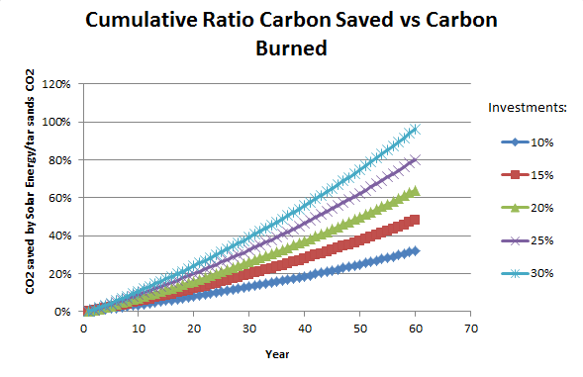

**Figure 6.** Amounts of CO2 offset with different investments in Solar Energy

**Table 4.** Amount of CO2 saved by not burning coal to produce energy by Solar

|  |  |
| --- | --- |
| Description | Value |
| Peak power of solar cell (MW) | 0.00130 |
| Percent land area assumed covered by PV fields | 10% |
| Area of PV farm (km2) | 14,020 |
| (Square miles) | 5,477 |
| Square size (miles x miles) | 74 |
| Land area per solar panel (km2) | 0.00163 |
| Number of solar panels to be built for land area | 8,590,686 |
| Density of coverage on land designated for PV fields | 30% |
| Area of PV cells (m2) | 4,206,000,000 |
| PV cell efficiency | 15% |
| Average 24/7 solar insolation April (Wh/m2/day) |  |
| June | 6,250 |
| January | 1,389 |
| Average power (assumes 24/7 operation made possible with storage technology) (GW) |  |
| June | 164 |
| January | 37 |
| Average | 100.405 |
| **CO2 saved by not burning coal to produce energy generated by solar (magatonnes/year)** | **854** |

## 4.2 Results from Investing in Solar Energy

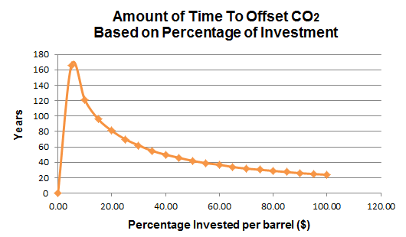

**Figure 7.** CO2 offset timelines with different investments in Solar Energy

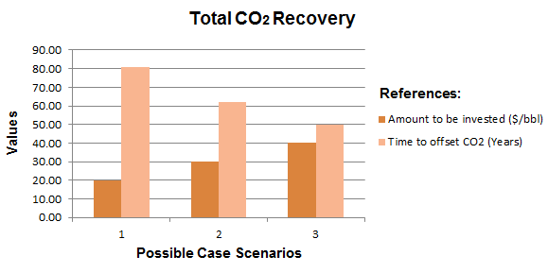

**Figure 8.** Case scenarios to offset CO2 with Solar Energy

**Estimated Results For Solar:**

* 15% Investment will produce an offset of CO2 in 96 years
* **20% Investment will produce an offset of CO2 in 81 years**
* 25% Investment will produce an offset of CO2 in 70 years
* 30 % Investment will produce an offset of CO2 in 62 years
* 40 % Investment will produce an offset of CO2 in 50 years

## 4.3 The Offset Percentage

To do

## 4.4 Assumptions

* **Peak Power of PV cell**
  + Assumption to be 1.3kW solar photovoltaic system. In Alberta, a cell will typically produce between 1000 and 1400 kWh per year [10]
  + Most solar panels come at roughly two sizes. We assume that this solar panel is 1600mm x 1020mm. [11]
* **Percent land covered by PV fields**
  + Assumption to cover 10% of land area
* **Density of coverage on land designated for PV fields**
  + Assumption to cover 30% of land area
* **Efficiency of PV fields**
  + For this analysis, OPV efficiency was estimated to be only 15%.
  + Dave DeGraaff, SunPower’s general manager, estimates PV cells efficiency to achieve 23% by 2015
* **Cost of installation of PV fields**
  + Estimated to be $4/W
* **Revenue generated**
  + All revenue generated gets reinvested into purchasing solar equipment. This includes the maintenance of solar panels

# 7 Discussion

**The EROI**

* Here is a way you can continue to mine and export oil sands while being completely carbon neutral.
* This is how you can make more money while spending less

**An alternative to the CO2 tax**

* This is an alternative to a CO2 tax
* Instead of paying a tax, this approach allows companies to invest into its own future and prevent forestall a CO2 tax
* Less opposition to building Keystone XL

**Spin-offs businesses**

* Electricity
  + Find out why Alberta is bringing electricity from BC? What are they looking into doing with it?
  + Sell Electricity
* Clean contaminated water with excess power from wind turbines
* Production of plastics and pesticides

# 8 Conclusion

It is appears to be economical and politically prudent to undertake as soon as possible a project to install 10 wind turbines on reclaimed land and study the project to ascertain true costs, risks, and benefits with respect to ultimately widespread application of this reclamation strategy.

In parallel, it would be good to conduct a detailed business analysis (short and long term return of investment ROI) of the hypotheses presented here, including:

1. The requirement of investing 20% of gross income from oil sands into renewable energy sources as part of land reclamation and to provide electricity for processing the oil sands, and then selling excess electricity back to the grid.
2. The ability of a) above to encourage the US to approve of the Keystone pipeline
3. The time effect cost of releasing a lot more CO2 now in exchange for a long term greater reduction.

# References

[1] Attanasi, Emil D.; Meyer, Richard F. [*"Natural Bitumen and Extra-Heavy Oil*"](http://www.worldenergy.org/documents/ser_2010_report_1.pdf) (PDF). Survey of energy resources (22 ed.). [World Energy Council](http://en.wikipedia.org/wiki/World_Energy_Council). pp. 123–140. 2010.

[2] *About Oil Sands: Facts and Statistics*. Retrieved March 13, 2014, from

http://www.energy.alberta.ca/oilsands/791.asp

[3] http://www.scientificamerican.com/article/oil-sands-and-keystone-xl-pipeline-impact-on-global-warming/

[4] U.S Department of State. *The final environmental impact statement*

*(FEIS).* January 2014

[5] Prystupa, Mychaylo. *Alberta doctor tells U.S.: Canada is lying about oil*

*sands health effects*. Retrieved Feb 27, 2014, from

https://www.vancouverobserver.com/news/

[6] *Oil Shale/Oil Sands Guide.* Retrieved March 13, 2014, from

http://ostseis.anl.gov/guide/oilsands/index.cfm

[7] R.D White (Robert Douglas), *Global Environmental Harm: Criminal Per-*

*pectives*. Cullompton, Devon; Portland, Or.: Willan Pub. 2010.

[8] Mettler, Peter. *Petropolis: Aerial Perspectives on the Alberta Oil Sands.*

Documentary. 2009.

[9] [*Alberta's Oil Sands: Opportunity, Balance*](http://www.environment.alberta.ca/documents/Oil_Sands_Opportunity_Balance.pdf). Government of Alberta. March 2008. Retrieved March 19, 2014.

[10] *1.41 kW Grid Tie Solar Power System; Edmonton, Alberta.* Retrieved March 23, 2014. http://www.skyfireenergy.com/

[11] *Solar Panel Dimensions*. Retrieved March 19, 2014. http://greenforcesolar.com.au

<http://spectrum.ieee.org/energywise/green-tech/solar/report-counts-up-solar-power-land-use-needs>

[12] Korosec, Kirsten. *97% of American Overestimate Cost of Installing Solar*. Retrieved March 19, 2014. http://www.smartplanet.com/

[13] *Carbon Sequestration Facts.* Retrieved March 19, 2014. http://www.forestecologynetwork.org.

[14] Loon, Jeremy Van. *Land of Oil Lakes.* Bloomberg Businessweek November 2013, Issue 4356, p15-16.

[15] Walsh, Bryan. *North Dakota Derailment Shows Dark Side of America's Oil Boom.* Time.com January 2014, p1-1-1

[16] Walsh, Bryan. *Report Raises No Major Climate Objections to Keystone Pipeline, But the Choice Is Obama's.* Time.com January 2014, p1-1-1

[17] Poisson et al*. A Time Series Analysis of Canadian Gas and Oil*. Nov 2013

[18] Kurek, et al. [*Legacy of a half century of Athabasca oil sands development recorded by lake ecosystems*](http://www.pnas.org/content/early/2013/01/02/1217675110.full.pdf). Proceedings of the National Academy of Sciences of the United States of America (National Academy of Sciences of the United States of America): 1–6. Retrieved 9 January 2013.